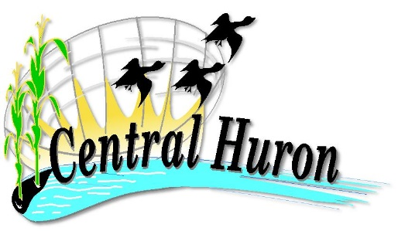

DONATION FUND
The Municipality of Central Huron is pleased to announce their annual Central Huron Donation Fund. The Municipality will again set aside funds to assist and promote community-based non-profit organizations. Funding is also available for national and international non-profit organizations provided that they have a local branch or affiliate and whose programs demonstrate a direct benefit for the residents of our Municipality. Organizations and/or community groups whose primary focus is not within the Municipality are eligible to apply for donations, however preference will be given to organizations and/or charities whose primary focus is within the Municipality.
To Qualify
Organizations must be non-profit. Proposed programs or events must clearly demonstrate a direct social or economic benefit for residents of Central Huron. Successful organizations will be required to submit a post project report identifying the use of the funds.
Further information can be found on our website:https://www.centralhuron.ca/en/business-and-development/donation-fund.aspx

Application
Applications for funding should include:
- Description of program or event
- Date of program or event
- Organization budget for proposed program or event
- Targeted resident group, if appropriate
- Supporting information including statistics for previous similar projects
- Amount of funding requested, specifying whether a cash or in-kind donation is required.

If your organization has questions or comments they should be directed to the undersigned at 519-482-3997 Ext. 1230 or email records@centralhuron.com.

Applications clearly marked Central Huron Donation Fund are to be received by the undersigned no later than 4:30 p.m. Thursday March 31, 2022:
Nicole Lowe, Records Clerk
Municipality of Central Huron
23 Albert Street
Clinton, Ontario N0M 1L0
records@centralhuron.com

